|  |
| --- |
| **Кировский машиностроительный завод**  **конвейерного оборудования**  **ООО «КИРОВМАШХОЛДИНГ»**  **ИНН 4345461881, КПП 434501001**  **610035, г.Киров, ул. Производственная, д.45**  **тел. +7 (8332) 42-44-42 , 8 (800) 550-34-42**  **cайт**: [**kirovmash.com**](http://kirovmash.com/) **email**: [**zakaz@kirovmash.com**](mailto:zakaz@kirovmash.com) |

# ОПРОСНЫЙ ЛИСТ

**для заказа нижних прямых роликоопор.**

**Контактная информация о ЗАКАЗЧИКЕ:**

Компания:_________________________________________________________________________________________________________

Контактное лицо:_____________________________________________ Должность____________________________________________

Адрес_____________________________________________________________________________________________________________

Телефон/факс:_______________________________________________ Эл. почта:______________________________________________

Дата заполнения__________________201__г.

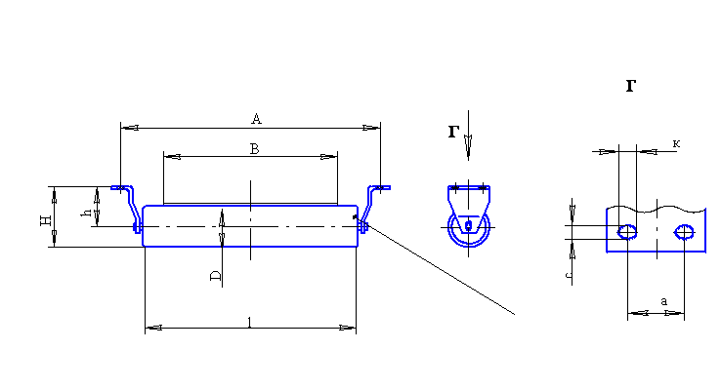

|  |  |  |  |  |  |  |  |  |  |  |  |  |
| --- | --- | --- | --- | --- | --- | --- | --- | --- | --- | --- | --- | --- |
| **Ширина ленты В, мм** | **Типоразмер роликоопоры** | **Рис.** | **Размеры, мм** | | | | | | | | **Примечания** | |
| **D** | **H** | **h** | **l** | **A** | **a** | **с** | **k** | **Кол-во, шт** | **Примечания** |
|  |  |  |  |  |  |  |  |  |  |  |  |  |
|  |  |  |  |  |  |  |  |  |  |  |  |  |
|  |  |  |  |  |  |  |  |  |  |  |  |  |
|  |  |  |  |  |  |  |  |  |  |  |  |  |
|  |  |  |  |  |  |  |  |  |  |  |  |  |
|  |  |  |  |  |  |  |  |  |  |  |  |  |
|  |  |  |  |  |  |  |  |  |  |  |  |  |
|  |  |  |  |  |  |  |  |  |  |  |  |  |
|  |  |  |  |  |  |  |  |  |  |  |  |  |
|  |  |  |  |  |  |  |  |  |  |  |  |  |
|  |  |  |  |  |  |  |  |  |  |  |  |  |